Testing a Population Proportion
$$H_{0}:p=p_{0}$$ |  |  |  | $$H_{0}:p=p_{0}$$ |  |  |  |  | $$H_{0}:p=p_{0}$$
$$H_{a}:p<p_{0}$$ |  |  |  | $$H_{a}:p>p_{0}$$ |  |  |  |  | $$H_{a}:p≠p_{0}$$
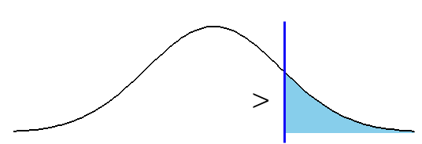  $z$ |  |  |  | $z$ |  |  |  |  | 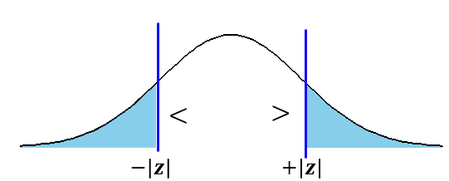
Test (z-) statistic: |  | $$z=\frac{\overline{p}-p_{0}}{\sqrt{\frac{p_{0}(1-p_{0})}{n}}}$$ |  | Conditions for Valid hypothesis test
   | Expected # of obs
  Success | $$np_{0}≥5$$
  Failure | $$n-np_{0}≥5$$
Interpretation of z-statistic |  |  | The proportion we observed in the sample is lower than /higher than /different from the proportion under Ho by (value of z-statistic) standard deviations.
Interpretation of $p$-value |  |  | There is a (value of $p$-value) probability that the sample proportion is  lower than /higher than /different from the proportion under Ho  by (value of z-score) standard deviations or more.
Likelihood  Function | $$L\left(p\right)=const*p^{x}{\left(1-p\right)}^{n-x} \\ l\left(p\right)=x\ln{p}+\left(n-x\right)\ln\left(1-p\right)+\ln{const}$$
Likelihood Ratio Test: |  | $$R=\frac{L\left(p_{0}\right)}{L(\overline{p})}$$  $χ^{2}=-2\ln{R}$ Chi-Square Distribution with $df=1$ |  |  |  |  |  | where  $p_{0}$ is the population proportion under Ho  $\overline{p}$ is the sample proportion

Confidence Interval for a Population Proportion
$$\overline{p}±z_{c} \sqrt{\frac{\overline{p}\left(1-\overline{p}\right)}{n}}$$ | Conditions for Valid Confidence Interval
   | Observed # of obs
  Success | $$x=n\overline{p}≥5$$
  Failure | $$n-x≥5$$
Confidence Level | 90% | 95% | 99%
$$z_{c}$$ | 1.645 | 1.95 | 2.576

Properties | When using a higher confidence level (e.g. 99%) to estimate a population mean,  - the interval becomes wider, resulting in  - higher certainty but lower precision in the estimate  When using a lower confidence level (e.g. 90%)  - the interval becomes shorter, resulting in  - lower certainty but higher precision in the estimate

Comparing Two Proportions
$$H_{0}:p_{1}=p_{2}$$ |  | $$H_{0}:p_{1}=p_{2}$$ |  | $$H_{0}:p_{1}=p_{2}$$
$$H_{a}:p_{1}<p_{2}$$ |  | $$H_{a}:p_{1}>p_{2}$$ |  | $$H_{a}:p_{1}≠p_{2}$$
$z$ |  | $z$
Test (z-)statistic: | $$z=\frac{{\overline{p}}_{1}-{\overline{p}}_{2}}{\sqrt{p\left(1-p\right)\left(\frac{1}{n_{1}}+\frac{1}{n_{2}}\right)}}, p=\frac{x_{1}+x_{2}}{n_{1}+n_{2}}$$
Interpretation of z-statistic | The difference between two sample proportions is (value of z-statistic) standard deviatons
Confidence Interval  for the $p_{1}-p_{2}$ | $$\left({\overline{p}}_{1}-{\overline{p}}_{2}\right)±z_{c}* \sqrt{\frac{{\overline{p}}_{1}\left(1-{\overline{p}}_{1}\right)}{n_{1}}+\frac{{\overline{p}}_{2}\left(1-{\overline{p}}_{2}\right)}{n_{2}}}$$
Conditions for Valid hypothesis test / Confidence Interval
   | Observed # of obs
   | Sample 1 | Sample 2
  Success | $$x_{1}≥5$$ | $$x_{2}≥5$$
  Failure | $$n-x_{1}≥5$$ | $$n-x_{2}≥5$$

Comparing More Two Population Proportions
$H_{0}:$ $p_{1}=p_{2}=p_{3}=…$
$H_{a}:$ At least one proportion is different from the others
Under $H_{0}$, the proportion of interest is estimated by pooling the data across all samples:
$$p_{0}=\frac{x_{1}+x_{2}+x_{3}+…}{n_{1}+n_{2}+n_{3}+…}$$

Chi-Square $=$ | $$\frac{n_{1}{\left({\overline{p}}_{1}-p_{0}\right)}^{2}}{p_{0}(1-p_{0})}+\frac{n_{2}{\left({\overline{p}}_{2}-p_{0}\right)}^{2}}{p_{0}(1-p_{0})} +\frac{n_{3}{\left({\overline{p}}_{3}-p_{0}\right)}^{2}}{p_{0}(1-p_{0})}+…$$
p-value | $$1-pchisq( chisq.stat, df=\#of groups-1)$$

